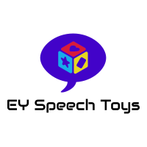Purchase order

For School’s and Nurseries needing to make purchases via purchase order, please:

1. Complete the form below and email to [alison@richmondspeechtherapy.co.uk](mailto:alison@richmondspeechtherapy.co.uk)
2. An invoice will be emailed to you
3. Pay the invoice
4. Goods will be shipped following payment

|  |  |
| --- | --- |
| **Buyer Details**  Contact name:  Contact email:  Business name:  Business address:  Date:  Purchase order number (optional): | **Seller details**  EY Speech Toys  27 Richmond Road,  Isleworth,  Middlesex,  TW7 7BS  email: [alison@richmondspeechtherapy.co.uk](mailto:alison@richmondspeechtherapy.co.uk) |
| **Shipping Details**  Contact name:  Shipping Address: | |
| **Order Details** | |
| Item | Quantity |
|  |  |
|  |  |
|  |  |
|  |  |
|  |  |
|  |  |
|  |  |
|  |  |
|  |  |
|  |  |
|  |  |